CHAPTER-1
INTRODUCTION
Iris Flower Classification

1.1 Introduction of project:
The Iris Flower Classification is a simple and popular example used in machine learning. It is based on a small dataset created by Ronald A. Fisher in 1936, which has information about three types of iris flowers: Setosa, Versicolor, and Virginica. Each flower is described by four features — the length and width of its sepals and petals. The main aim is to predict the type of flower by looking at these features.
This problem is often used by beginners to learn how classification works in machine learning. Different methods like Logistic Regression, Decision Trees, SVM, Random Forests, or K-Nearest Neighbors are applied to solve it. Since the dataset is small and easy to understand, it helps learners practice data handling, training models, and testing predictions. Even though it is simple, the concepts learned from this problem are useful for real-world tasks like identifying plants, animals, or objects using data.

1.2 Objective of project:
- Understand the Dataset – To study the Iris dataset and explore its features (sepal length, sepal width, petal length, petal width) to see how they help in identifying the flower species.
- Apply Machine Learning Techniques – To implement and compare different classification algorithms such as Logistic Regression, Decision Trees, SVM, Random Forest, or KNN.
- Build a Predictive Model – To train a model that can accurately classify a flower into one of the three species: Setosa, Versicolor, or Virginica.
- Data Visualization – To use graphs and plots to better understand the relationships between features and how they separate the species.
- Model Evaluation – To test the performance of the model using accuracy, confusion matrix, or other metrics and ensure reliable predictions.

1.3 Category:
Machine Learning (based)

1.4 Language to be used:
Front end
1.4.1 Desktop UI (simpler option):
- Streamlit
Back end
ML Libraries: Scikit-learn.

1.5 Hardware interface:
- Processor: Intel i5 or above
- RAM: 8 GB or more
- 25 GB SSD

1.6 Software interface:
Operating System: Windows 10 or above / Ubuntu 18.04+
- IDE: VS Code
- Python Version: 3.7+ -
- Browser: Chrome / Firefox

1.7 Description:
The Iris Flower Classification project is a simple machine learning project using the Iris dataset that includes three species: Setosa, Versicolor, and Virginica. Each flower is described by four features — sepal length, sepal width, petal length, and petal width. The main aim is to build a model that can predict the species of a flower based on these measurements. Different algorithms like Logistic Regression, Decision Trees, KNN, Random Forest, and SVM are applied and compared.
This project serves as an excellent introduction to supervised machine learning, particularly for beginners learning about classification algorithms such as Logistic Regression, Decision Trees, and Support Vector Machines (SVM). The simplicity and small size of the dataset make it ideal for understanding the complete process of building a predictive model — from data preprocessing and visualization to training, testing, and evaluation. The Iris Flower Classification is often used in educational settings to demonstrate fundamental concepts in data science and machine learning.

1.8 Module description:
1.8.1 User Input Module
The User Input Module is designed to collect and manage the data entered by the user, such as the flower’s sepal length, sepal width, petal length, and petal width. It provides an intuitive and user-friendly interface with clearly labeled input fields, allowing users to enter the measurements easily. This module ensures smooth interaction between the user and the system, enabling efficient data submission for prediction.
Additionally, the module performs validation checks to ensure that all input values are numeric, within valid ranges, and free from errors. If any invalid or missing data is detected, the user receives instant feedback to correct the input. Once validated, the data is passed to the preprocessing and model prediction modules for further processing, ensuring accuracy and reliability in results.

1.8.2 Preprocessing Module
The Preprocessing Module is responsible for preparing the user’s input data before it is used for prediction. It ensures that the input values are properly formatted, cleaned, and standardized according to the model’s requirements. This may include scaling or normalizing the input
features to match the conditions under which the model was trained. Moreover, the module checks for inconsistencies or extreme values that might affect prediction accuracy. By maintaining consistency and quality in the input data, this module ensures that the model receives well-structured information, thereby improving prediction accuracy and system performance.

1.8.3 Model Prediction Module
The Model Prediction Module is the core of the Iris Flower Classification system. It uses a pre-trained machine learning model (such as Logistic Regression, SVM, Random Forest, or K-Nearest Neighbors) to analyze the preprocessed input data and predict the flower species Setosa, Versicolor, or Virginica.
This module applies the trained model’s learned patterns to new data and generates accurate predictions efficiently. It supports both single and multiple predictions and ensures the output is displayed clearly to the user.

1.8.4 Streamlit UI Module
The Streamlit UI Module provides a simple and interactive web-based interface for users to interact with the Iris Flower Classification system. Built using the Streamlit framework, it allows users to input flower measurements, select a prediction model, and view the predicted species and confidence scores in real time.
Furthermore, this module enhances the user experience with clean layouts, instant feedback, and visual representations of results. It connects the backend machine learning model with the frontend interface, enabling real-time interaction without requiring programming knowledge. The Streamlit UI Module ensures that the entire prediction process — from input to output — is seamless, efficient, and user-friendly.

1.9 Limitations:
- Data Collection Module – Uses the Iris dataset containing 150 samples of three flower species with four features each.
- Data Preprocessing Module – Cleans the dataset, handles scaling or normalization, and prepares data for training.
- Data Visualization Module – Creates graphs and plots to understand feature relationships and how species differ.
- Model Training Module – Applies machine learning algorithms (Logistic Regression, Decision Trees, KNN, Random Forest, SVM) to train classification models.
- Model Evaluation Module – Tests models using accuracy, confusion matrix, or other metrics to find the best-performing one.

CHAPTER-2
SOFTWARE REQUIREMENT SPECIFICATION

2.1 Introduction:
The software should allow users to enter flower features like sepal and petal measurements. It must predict the flower species (Setosa, Versicolor, or Virginica) accurately. Functional requirements include data input, model training, prediction, and result display. Non-functional requirements include accuracy, reliability, and user-friendly operation.

2.2 Purpose:
The purpose of this project is to build a system that can automatically identify the species of an iris flower based on its measurements. It helps users understand how machine learning can be applied to real-world classification problems. The project also provides hands-on experience in data analysis, model training, prediction, and evaluation, making it useful for learning and practical applications in fields like botany and agriculture.

2.3 Scope:
- Classify iris flowers into three species: Setosa, Versicolor, and Virginica.
- Apply machine learning algorithms for accurate flower species prediction.
- Train and test models using the standard Iris dataset.
- Analyze relationships between flower features (sepal and petal length/width).
- Implement data preprocessing, visualization, and evaluation techniques.
- Use the project as a benchmark for testing various classification algorithms.
- Compare performance of algorithms like Logistic Regression, Decision Tree, KNN, and SVM
- Extend the methods to other plant or biological classification problems.
- Serve as an educational project for beginners in data science and ML.

2.4 Definition, Acronyms, Abbreviation:
Table No.2.4:Abbreviation used in the Report
Term | Description
Iris Dataset | A dataset containing measurements of iris flowers used to classify them into different species.
Sepal Length | The length of the sepal of the flower, measured in centimeters.
Sepal Width | The width of the sepal of the flower, measured in centimeters.
Petal Length | The length of the petal of the flower, measured in centimeters.
Petal Width | The width of the petal of the flower, measured in centimeters.
Setosa | One of the three iris flower species with small petals and sepals.
Versicolor | The second species of iris flowers with medium-sized petals and sepals.
Virginica | The third species of iris flowers with larger petals and sepals.

2.5 Overview:
The Iris Flower Classification project is a machine learning project that predicts the species of an iris flower using its sepal and petal measurements. It uses the Iris dataset containing three species: Setosa, Versicolor, and Virginica. Different algorithms like Logistic Regression, KNN, Decision Trees, and SVM are applied to train and test the models.

2.6 Overall description:
The Iris Flower Classification project predicts the species of an iris flower using its sepal and petal measurements. It uses a dataset of 150 flowers from three species: Setosa, Versicolor, and Virginica, and applies machine learning algorithms like Logistic Regression, KNN, and SVM. The project helps learners practice data analysis, model training, and prediction.

2.7 Productive perspective:
The project is a standalone machine learning application that predicts the species of an iris flower based on its features. It can be integrated with larger systems for plant identification or botanical research. The system uses a structured dataset and applies classification algorithms to provide accurate predictions.

2.8 Product Function :
- Data Input – Allows users to enter flower measurements (sepal length, sepal width, petal length, petal width).
- Data Prepossessing – Cleans and prepares the datasets for model training.
- Model Training – Trains machine learning algorithms like Logistic Regression, KNN, Decision Trees, and SVM.
- Prediction – Predicts the species of the flower based on input features.
- Result Display – Shows the predicted species and, optionally, the confidence of the prediction.
2.9 Browser That Supports:
- Google chrome
- Microsoft edge
- Mozilla
- Firefox

2.10 User classes and characteristics:
- End Users: Individuals who want to identify the species of an iris flower using its measurements. Basic computer knowledge is sufficient to use the system.
- Administrators: Optional users who manage the datasets, update features, and retrain the machine learning models for better accuracy.

2.11 Assumptions and Dependencies:
- Python and required libraries (like NumPy, Pandas, Sci kit-learn, Matplotlib) are installed on the system.
- The Iris dataset is available and correctly formatted.
- Input measurements (sepal and petal length/width) are accurate and in the correct units (centimeters).
- The system has sufficient computational resources to train and run machine learning models.
- An internet connection may be required to download libraries or additional datasets.
2.12 Specific Requirements:
User Interface:
- Input fields for sepal length, sepal width, petal length, and petal width.
- Button to submit the measurements for species prediction.
- Streamlit-based web interface for entering flower measurements.
- Output area showing the predicted species (Setosa, Versicolor, or Virginica).
2.13 Software Requirements:
- Operating System: Windows 10/11, Linux, macOS
- Programming Language: Python 3.x
- Libraries: Streamlit,NumPy,Joblib,OS
- Web Framework: Streamlit

2.14 Hardware Requirements:
- Processor: Intel i3 or above
- RAM: 4 GB minimum (8 GB recommended)
- Storage: 250 GB minimum
- Display, Keyboard, Mouse
- Internet connection for setup and library downloads

2.15 Communication Interface:
The communications function required by this product is HTTP protocol, and internet
communication is through TCP/IP protocol.

2.16 Functional Requirements:
- User Input Module: Accepts sepal and petal measurements via the user interface.
- Preprocessing Module: Validates and scales the input data for model prediction.
- Model Prediction Module: Loads the trained machine learning model and predicts the flower species.
- Streamlit UI Module: Displays the predicted species and confidence interactively to the user.
2.17 Performance Requirements:
- Prediction Speed: Flower species should be predicted within 2–3 seconds per input.
- Accuracy: The classification model should ideally achieve over 90% accuracy.
- Scalability: The system should handle multiple inputs and the full dataset without performance issues.
2.18 Design Constraints:
- Must use a Python-compatible environment.
- Front-end interface should be simple and user-friendly.
- Machine learning model must use the same preprocessing pipeline as during training.
- System performance depends on available computing resources (RAM, CPU).

2.19 System Attributes:
Table No.2.19: System Attributes with Description
S.No | Quality Attribute | Description
1 | Reliability | The system should consistently provide accurate predictions for flower species
2 | Efficiency | Predictions should be generated quickly, ideally within a few seconds per input
3 | Usability | The interface should be simple, intuitive, and easy for beginners to use.
4 | Maintainability | The system should allow easy updates, such as retraining the model with new data.
5 | Portability | The project should run on any system with Python and the required libraries installed.
6 | Scalability | The system should handle multiple inputs and larger datasets without performance issues.

2.20 Other Requirements:
- Software: Python 3.x with libraries like NumPy, Pandas, Scikit-learn, Matplotlib, and Streamlit; optional IDE like Jupyter Notebook or VS Code.
- Hardware: Minimum 4GB RAM, 2-core CPU, and sufficient storage for datasets and models.
- Data: Clean and structured Iris dataset; accurate flower measurements in centimeters.
- User & Environment: Basic computer skills; internet connection for downloading libraries or datasets; Python-compatible OS (Windows, Linux, or macOS).

CHAPTER - 3
SYSTEM DESIGN
3.1 Introduction:
System Design for the Iris Flower Classification Project is the process of defining the architecture, components, modules, interfaces, and data flow of the system to achieve the goal of predicting the species of an iris flower based on its features. It involves designing how user input, preprocessing, the machine learning model, and the output interface interact with each other to provide accurate and efficient flower classification.
In simple terms, system design explains how the system works — how the flower measurements (sepal length, sepal width, petal length, and petal width) flow through each module, how data is processed, and how the trained model predicts the correct flower species such as Setosa, Versicolor, or Virginica.
3.2 Context Flow Diagram:
A context diagram for an Iris Flower Classification, illustrates the entire system as a single process and its interactions with external entities. It provides a high-level overview without detailing internal processes.
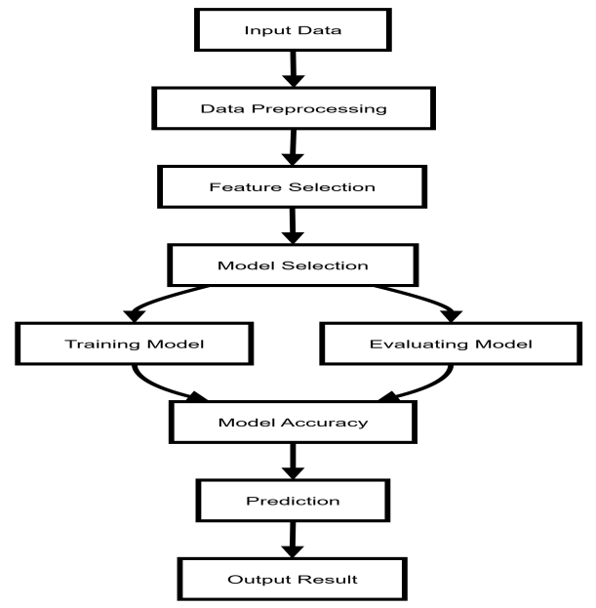

Fig No. 3.2:Context flow diagram

3.3 Data Flow diagram:
Data Flow Diagram is a graphical representation of a system or a portion of the system. It consists of data flows, process, sources and sink and stores all the description through the use of easily understandable symbols.
DFD is one of the most important modelling tools. It is used to model the system, components that interact with the system, uses the data and information flows in the system.
DFD shows the information moves through the and how it is modified by a series of transformations. It is a graphical technique that depicts information moves from input or output.
DFD is also knows as bubble chart or Data Flow Graphs. DFD may be used to represent the system at any level of abstraction. DFD‟s may partition into a level that represents increasing information flows and functional details.

3.4 Rules Regarding DFD construction:
- A process cannot have only outputs.
- A process cannot have only inputs.
- The inputs to a process must be sufficient to produce the outputs from the process.
- All data stores must be connected to at least one process.
- All data stores must be connected to a source or sink.
- A data flow can have only one direction of flow. Multiple data flows to and/or from the same process and data store must be shown by separate arrows.
- If the exact same data flows to two separate arrows, it should be represented by a forked arrow.

3.5 DFD DIAGRAM
Table No.3.5: Notation used in DFD
Name | Notation | Description
Process |  | A process transforms incoming data flow into outgoing data flow. The processes are shown by named circles.
Data store |  | Data stores are repositories of data in the system. They are sometimes also referred to as files.
Data flows |  | Data flows are pipelines through which packets of information flow. Label the arrows with the name of the data that moves through it.
External Entity |  | External entities are objects outside the system with which the system communicates. External Entities are sources and destinations of the systems inputs and outputs.

3.6 DFD Level 0:
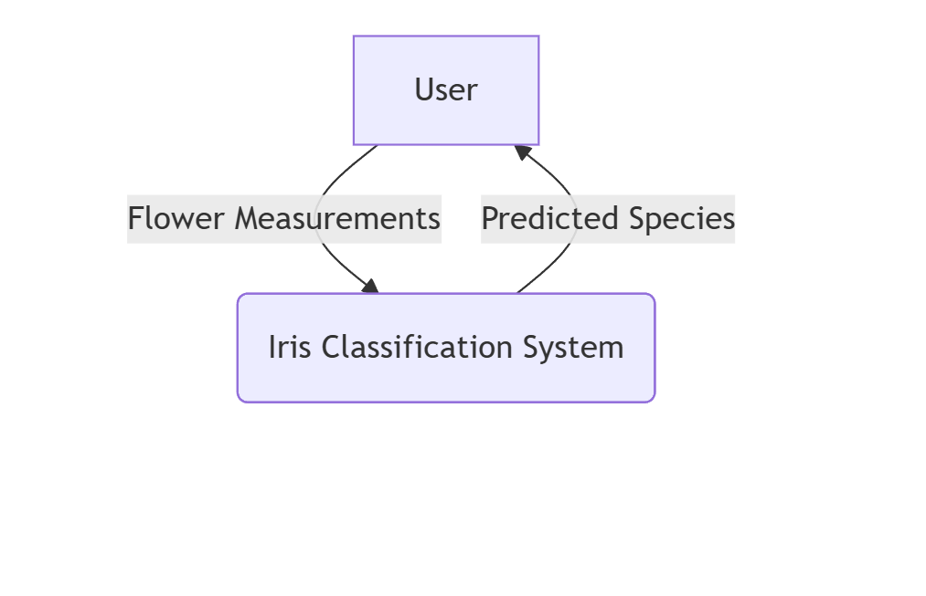
Fig No.3.6

3.6.1 DFD Level 1:

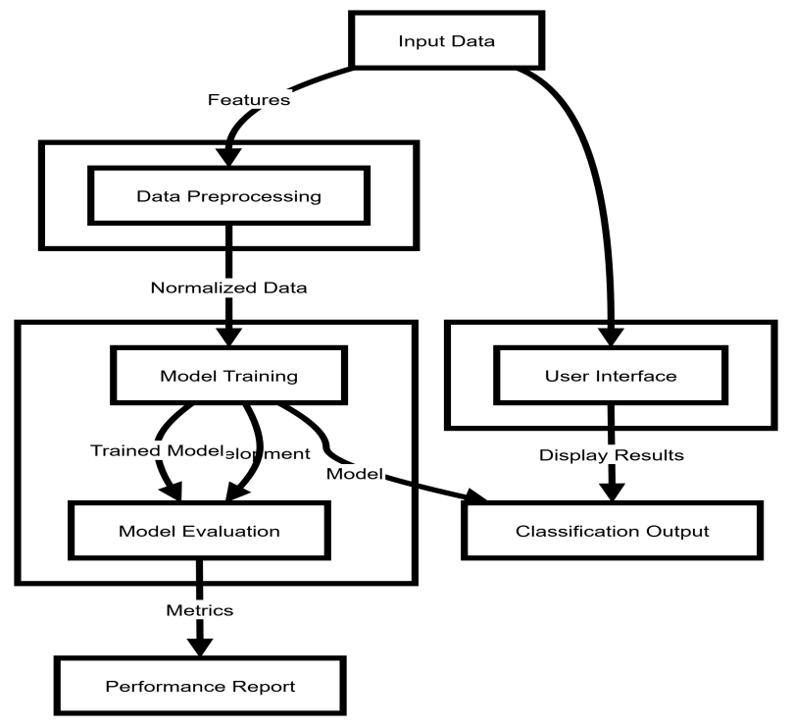

Fig No:3.6.1

3.6.2 DFD Level 2:
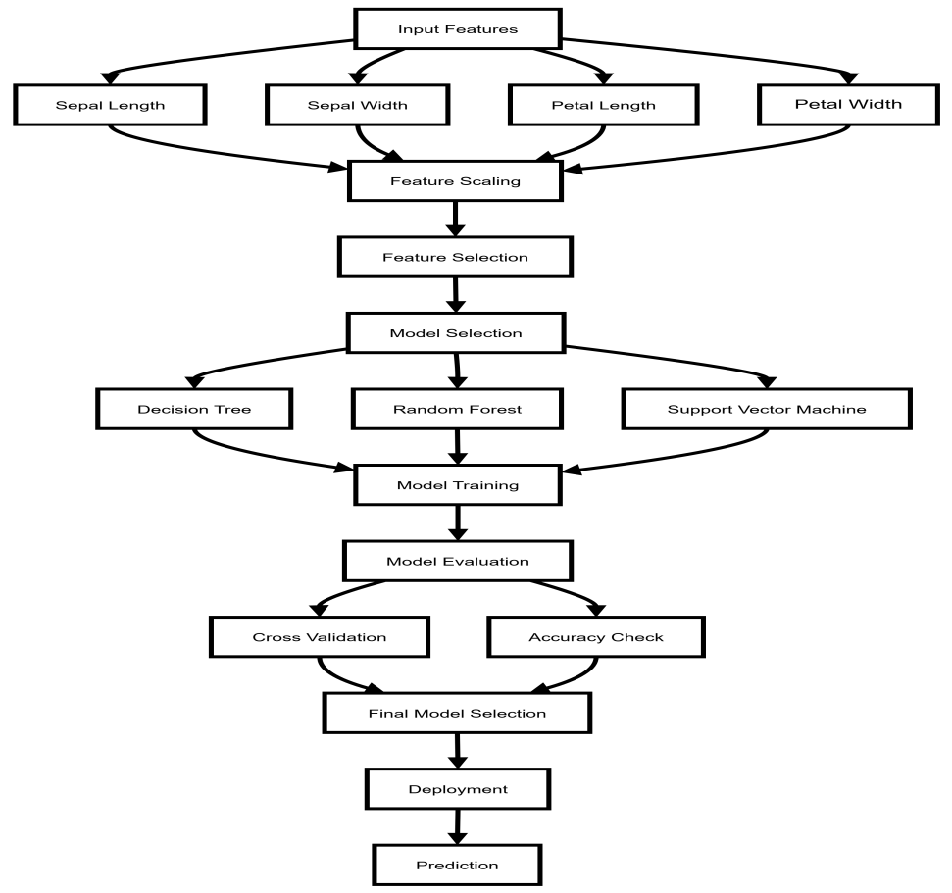

Fig No:3.6.2

3.7 Entity Relationship Diagram:
A set of primary components are identified for the ER Diagram: Data object, Attributes, Relationships and various type indicators. The primary purpose of the ER Diagram is to represent data objects and their relationships.

3.7.1 Data Objects:
A data object is a representation of almost any composite information that must be understood by software. Composite information refers to something that has a number of different properties or attributes.

3.7.2 Attributes:
Attributes defines the properties of data object and take on one of three different characteristics. They can be used to (1) name an instance of the data object (2) describe the instance or (3) make reference to another instance in another table. In addition, one or more of the attributes must be defined as an identifier that is the identifier attribute becomes a “key” when we want to find an instance of the data object.

3.7.3 Relationships:
Indicate the manner in which data objects are “connected” to one another.

3.7.4 Cardinality:
The data model must be capable of representing the number of occurrences objects in a given relationships. Tillman defines the cardinality of an object/relationships pair in the following manner: “Cardinality is the specification of the number of occurrences of one [object] that can be related to the number of occurrences of another [object]. Cardinality is usually expressed as simply „one‟ or „many‟”. Taking into consideration all combinations of „one‟ and „many‟, two [object] can be as:

The Symbols are shown in below table:
Table No. 3.7.4(a):Notation used in ER Diagram
Name | Notation | Description
Entity | Entity name | It may be an object with the physical existence or conceptual existence. It is represented by a Rectangle.
Attribute | Attribute name  Attribute name | The properties of the entity can be a attribute. It is represented by a Ellipse.
Relationship | Relation | Whenever an attribute of one entity refers to another entity, some relationship exists. It is represented by a Diamond.
Link |  | Lines link attributes to entity  sets an identity sets to relation.
Derived attribute | Attribute | Dashed ellipse denote derived attributes.
Key Attribute | Key attribute | An entity type usually has an attribute whose values are distinct for each individual entry in the entity set. It is represented by a Underlined word in ellipse.
Multi Valued  Attribute | Multi valued attribute | Attributes that have different numbers of values for a particular attribute. It is represented by a Double ellipse represents multi-valued  attributes.
Cardinality Ratio | - 1:1  - 1:M  - M:1  - M:M | It specifies the maximum number of relationships instances that an entity can participate in. There are four  cardinality ratios.

3.8 ER Diagram:

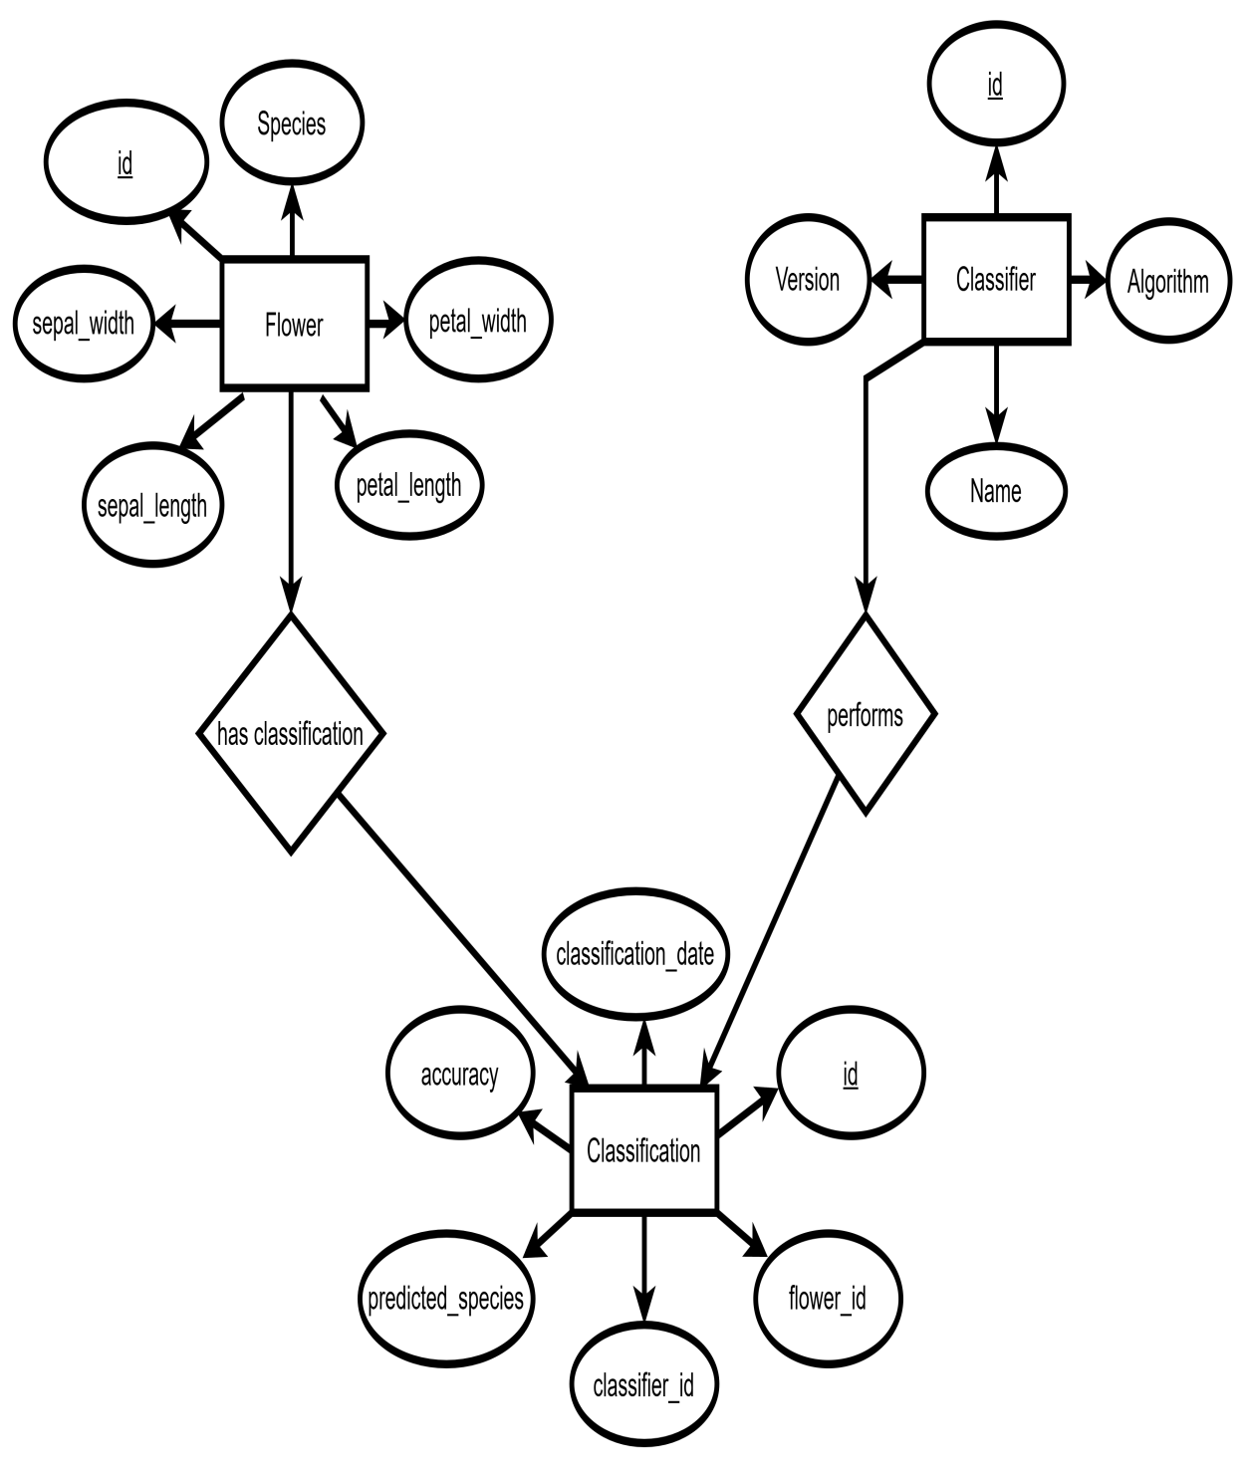

Fig No: 3.8

3.9 ER Model:

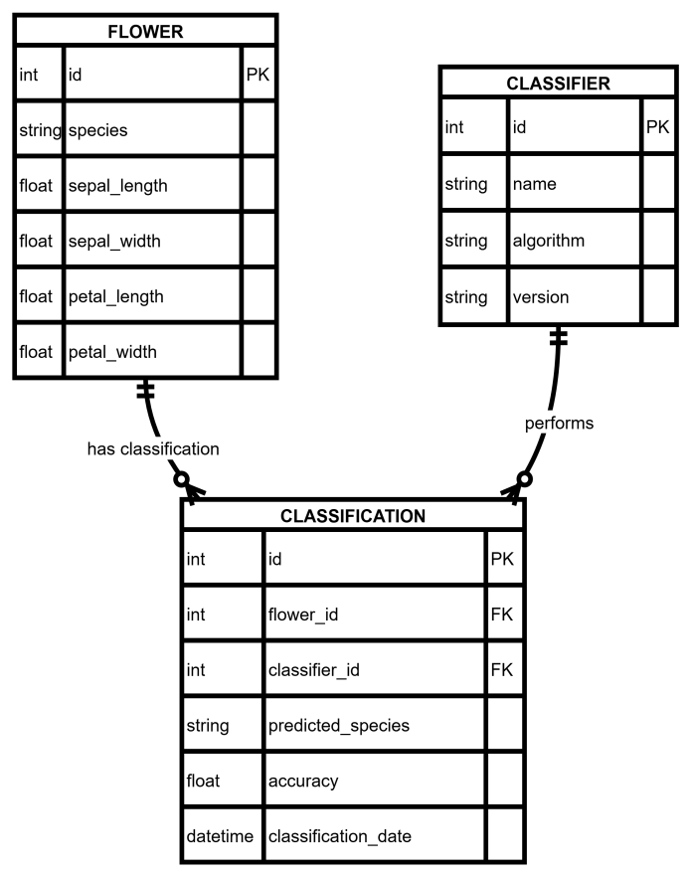

Fig no:3.9

CHATPER-4
DATABASE DESIGN

4.1 Introduction:
Database: A Database is collection of related data, which can be of any size and complexity. By using the concept of Database, we can easily store and retrieve the data. The major purpose of a database is to provide the information, which utilizes it with the information’s that the system needs according to its own requirements.

Database Design: Database design is done before building it to meet needs of end users within a given information-system that the database is intended to support.The database design defines the needed data and data structures that such a database comprises The database is physically implemented using MySQL.

4.2 The database tables:
- Flower_Species
- Flower_Features
- User_Input
- Prediction_Result
- Model_Info

4.3 Database structure:
4.3.1 Structure of Table ”Flower_Species”:
Table no. 4.3.1 Database structure of flower species
Field Name | Field Type | Size | Contraints | Description
species_id | int | 10 | PRIMARY KEY | Unique ID for each flower species
species_name | varchar | 50 | NOT NULL | Name of the species (Setosa, Versicolor, Virginica)
description | text | — | NULL | Additional details or characteristics of the species

4.3.2 Structure of Table “Flower_Features”
Table no. 4.3.2 Database structure of flower features
Field Name | Field Type | Size | Constraints | Description
feature_id | int | 10 | PRIMARY KEY | Unique ID for each feature record
species_id | int | 10 | FOREIGN KEY | References the species in Flower_Species table
sepal_length | float | — | NOT NULL | Sepal length of the flower
sepal_width | float | — | NOT NULL | Sepal width of the flower
petal_length | float | — | NOT NULL | Petal length of the flower
petal_width | float | — | NOT NULL | Petal width of the flower

4.3.3 Structure of Table “User_Input”
Table no. 4.3.3 Database structure of user input

Field Name | Field Type | Size | Contraints | Description
input_id | int | 10 | PRIMARY KEY | Unique ID for each user input
sepal_length | float | — | NOT NULL | Sepal length of the input flower
sepal_width | float | — | NOT NULL | Sepal width of the input flower
petal_length | float | — | NOT NULL | Petal length of the input flower
petal_width | float | — | NOT NULL | Petal width of the input flower

4.3.4 Structure of Table “Prediction_Result”:
Table no. 4.3.4 Database structure of prediction result

Field Name | Field Type | Size | Contraints | Description
prediction_id | int | 10 | PRIMARY KEY | Unique ID for each prediction
sepal_length | float | — | NOT NULL | Sepal length of the input flower
sepal_width | float | — | NOT NULL | Sepal width of the input flower

CHAPTER-5
DETAILED DESIGN
5.1 Introduction:
The detailed design phase describes the internal structure and working mechanism of the Iris Flower Classification System. It translates the high-level system architecture into specific modules, components, and data flows. The goal is to define how different components interact, how flower measurements are processed, and how the final prediction of the flower species (Setosa, Versicolor, or Virginica) is achieved using machine learning models.

5.2 Application Documents:
- Dataset Files – A collection of labeled iris flower samples with features (sepal length, sepal width, petal length, petal width) and species labels used for training and testing.
- Prepossessing Scripts – Scripts that clean, normalize, and scale the feature data to prepare for machine learning models.
- Feature Extraction Files – Documents or scripts that transform raw flower measurements into numerical vectors suitable for model input.
- Classification Reports – Output reports summarizing model performance, including accuracy, precision, recall, F1-score, and confusion matrix results.
- Configuration Files – Files that store system settings, model parameters, and thresholds to ensure reproducibility of predictions.

5.3 Structure of the Software Package and Components:
- Data Collection Module
Responsible for importing the Iris dataset containing flower measurements and species labels.
- Preprocessing Module
Cleans, normalizes, and scales the flower feature data to prepare it for model training.
- Feature Extraction Module
Converts raw flower measurements into numerical features suitable for machine learning models.
- Machine Learning Model Module
Implements classification algorithms such as Logistic Regression, KNN, Decision Trees, Random Forest, or SVM.
Provides model training, testing, and validation.
- Prediction Engine
Uses the trained model to predict the species of new iris flower inputs.
- Storage and Database Module
Stores raw datasets, processed data, prediction results, and model information.
- User Interface (UI) Module
Provides a user-friendly interface for entering flower measurements and viewing predicted species and confidence scores.

5.4 Modular Decomposition of Components:
5.4.1 User Input Module
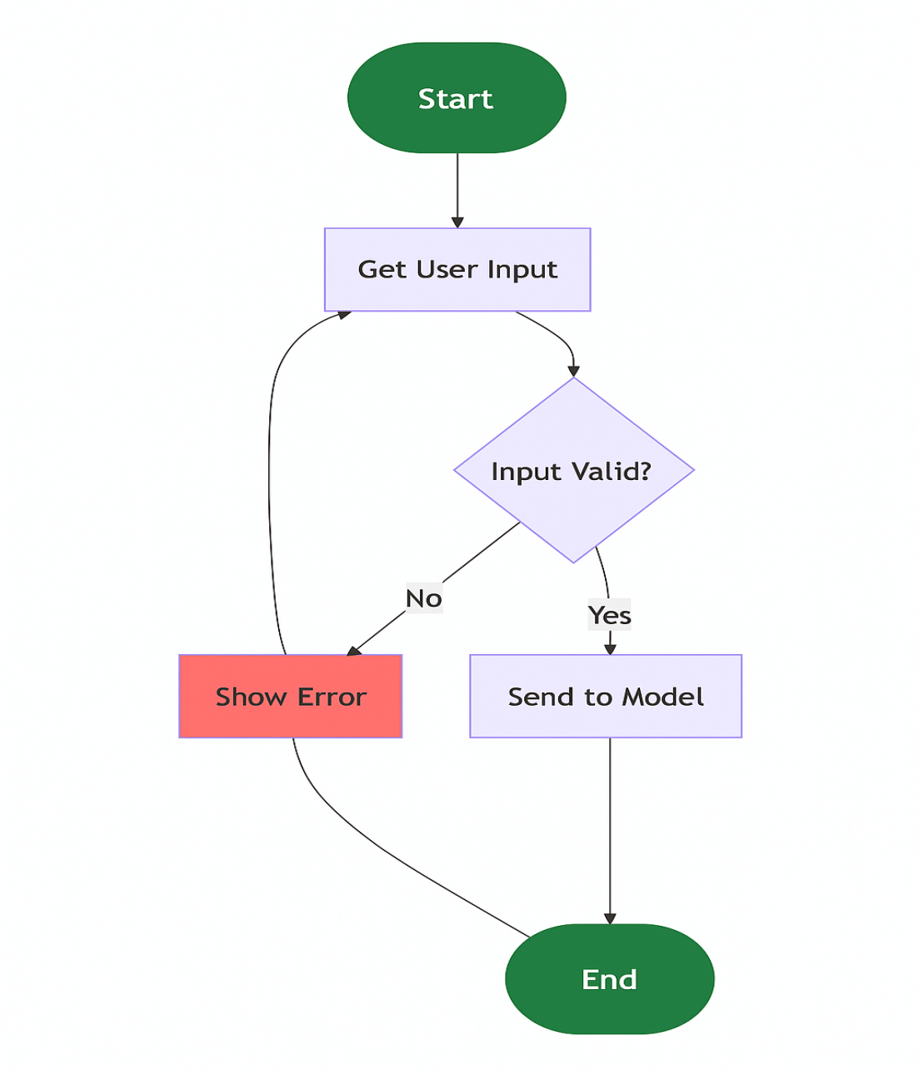

Fig No.5.4.1:Flow chart for User Input Module

5.4.2 Preprocessing Module

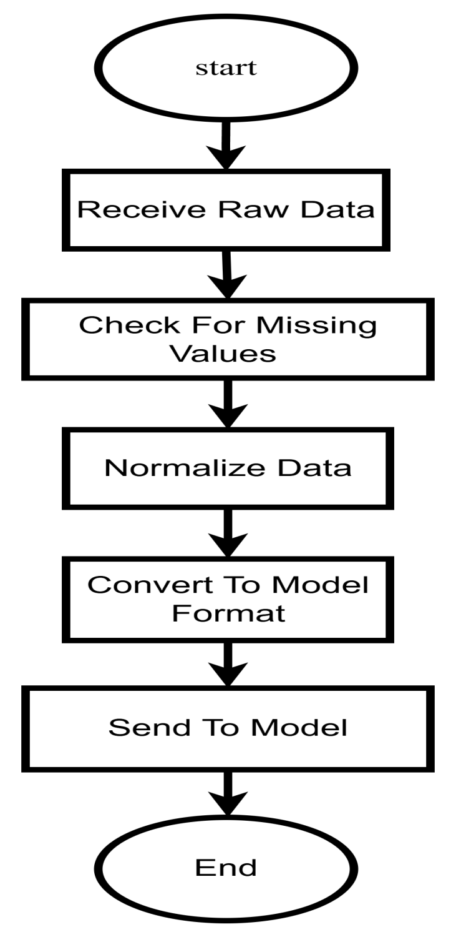

Fig No.5.4.2: Flow chart for Preprocessing Module

5.4.3 Model Prediction Module
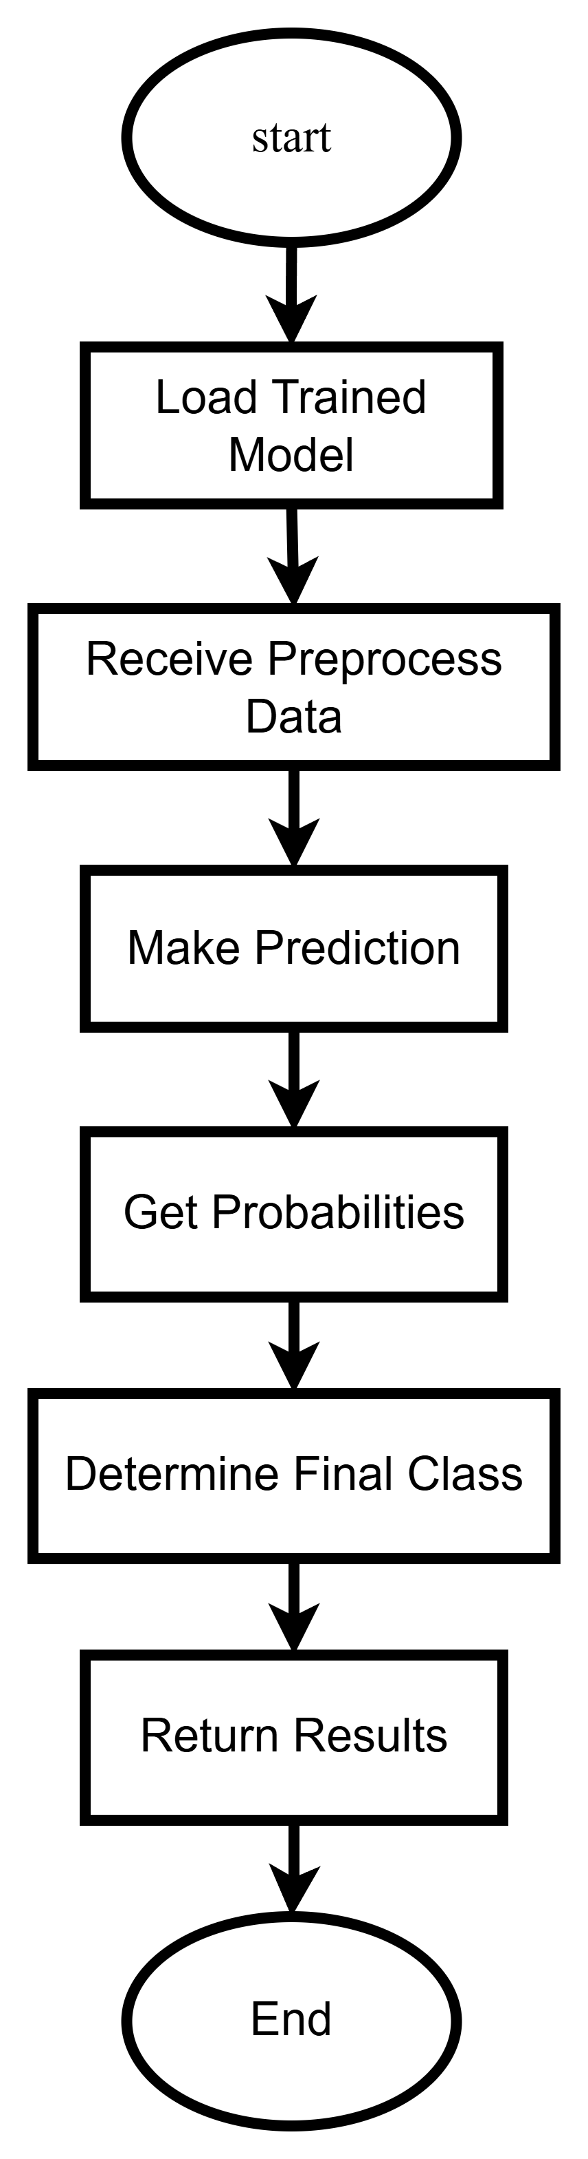

Fig No.5.4.3: Flow chart for Model Prediction Module

5.4.4 Streamlit UI Module

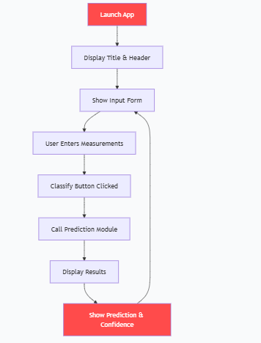

Fig No.5.4.4: Flow chart for Streamlit UI Module

CHAPTER-6
IMPLEMENTATION

import streamlit as st
import numpy as np
import joblib
import os

class IrisInterface:
def __init__(self):
self.models = {}
self.scaler = None
self.target_names = ['setosa', 'versicolor', 'virginica']
self.load_models_and_scaler()

def load_models_and_scaler(self):
model_names = ['logistic_regression', 'svm', 'random_forest', 'k-nearest_neighbors']
for name in model_names:
model_path = f"{name}_model.pkl"
if os.path.exists(model_path):
self.models[name] = joblib.load(model_path)
else:
st.error(f"Model file {model_path} not found.")
scaler_path = "scaler.pkl"
if os.path.exists(scaler_path):
self.scaler = joblib.load(scaler_path)
else:
st.error("Scaler file scaler.pkl not found.")

def predict(self, sepal_length, sepal_width, petal_length, petal_width, model_key):
model = self.models.get(model_key)
if model is None:
st.error(f"Model {model_key} not loaded.")
return None, None

sample = np.array([[sepal_length, sepal_width, petal_length, petal_width]])
if model_key in ['logistic_regression', 'svm', 'k-nearest_neighbors']:
sample_scaled = self.scaler.transform(sample)
prediction = model.predict(sample_scaled)
probabilities = model.predict_proba(sample_scaled)
else:
prediction = model.predict(sample)
probabilities = model.predict_proba(sample)

predicted_class = self.target_names[prediction[0]]
return predicted_class, probabilities[0]

def main():
st.title("Iris Flower Species Prediction")
st.write("Enter the measurements of the iris flower:")

sepal_length = st.number_input("Sepal Length (cm)", min_value=0.0, max_value=10.0, value=5.1)
sepal_width = st.number_input("Sepal Width (cm)", min_value=0.0, max_value=10.0, value=3.5)
petal_length = st.number_input("Petal Length (cm)", min_value=0.0, max_value=10.0, value=1.4)
petal_width = st.number_input("Petal Width (cm)", min_value=0.0, max_value=10.0, value=0.2)

model_options = {
"Logistic Regression": "logistic_regression",
"SVM": "svm",
"Random Forest": "random_forest",
"K-Nearest Neighbors": "k-nearest_neighbors"
}
model_choice = st.selectbox("Select Model", list(model_options.keys()))

if st.button("Predict"):
interface = IrisInterface()
predicted_class, probabilities = interface.predict(

sepal_length, sepal_width, petal_length, petal_width, model_options[model_choice]
)
if predicted_class:
st.write(f"Predicted Species: **{predicted_class}**")
st.write("Confidence Scores:")
for species, prob in zip(interface.target_names, probabilities):
st.write(f"- {species}: {prob:.4f}")

# Display saved plots
st.subheader("Data Visualizations")
st.image("pairplot.png", caption="Pairplot of Iris Dataset by Species")
st.image("distribution_plots.png", caption="Distribution Plots by Species")
st.image("correlation_heatmap.png", caption="Feature Correlation Heatmap")
st.image("confusion_matrix.png", caption="Confusion Matrix of Best Model")

if __name__ == "__main__":
main()

CHAPTER-7
SOFTWARE TESTING

7.1 Introduction:
Testing is a crucial phase in the development of the Iris Flower Classification System, as it ensures that the system predicts flower species accurately, consistently, and efficiently. The purpose of testing is to identify defects, validate functionality, and ensure that the software meets user requirements. Different levels of testing are conducted, from unit-level validation of individual modules (like data preprocessing and model training) to system-level testing and user acceptance, ensuring the overall reliability of predictions.

7.2 Testing Objectives:
- To verify that each module of the system, such as data input, preprocessing, and model prediction, functions as expected.
- To validate the accuracy of flower species classification against the Iris dataset.
- To ensure proper integration between data preprocessing, feature extraction, and machine learning model modules.
- To test performance metrics (accuracy, precision, recall, F1-score) and confirm they meet acceptable thresholds.
- To evaluate user interaction with the system through the input interface and result .
7.3 Testing Steps:
7.3.1 Unit Testing
Purpose: Tests individual functions or components in isolation.
Examples:
- Input validation for flower measurements
- Data preprocessing functions (e.g., scaling, normalization)
- Feature extraction for model input
7.3.2 Integration Testing
Purpose: Ensures that different modules of the system work well together.
Examples:
- Preprocessing pipeline + feature scaling + model prediction
- Input measurements → Full pipeline → Output predicted species
7.3.3 Functional Testing
Purpose: Verifies that the system behaves as expected for given inputs.
Examples:
- A flower with known measurements is classified correctly
- The system handles edge cases (e.g., zero or negative values)
7.3.4 Performance Testing
Purpose: Measures how fast and efficient the system is.
Examples:
- Time taken to predict species for a single input
- System performance when classifying multiple flowers at once
7.3.5 Load Testing
Purpose: Checks the system's performance under heavy load.
Examples:
- Classifying hundreds or thousands of flower samples simultaneously
- Monitoring memory and CPU usage during peak operations

7.3.6 Security Testing
Purpose: Ensures that the system handles invalid or malicious inputs safely.
Examples:
Testing against invalid measurements or incorrect data types

7.4 Test Cases for Iris Flower Classification
7.4.1 Input Validation Test Cases
Table No.7.4.1: Test cases for input validation
Test Case ID | Description | Input | Expected Output
TC001 | Empty flower measurements | "" | Return error or prompt for valid input
TC002 | Measurements with only zeros | 0, 0, 0, 0 | Handled without crash, likely flagged as invalid
TC003 | Very large/invalid values | 1000, 2000, 1500, 3000 | Handled gracefully, error or validation message
TC004 | Negative measurements | -5, -3, -2, -1 | Handled correctly, prompt for valid input
TC005 | Non-numeric input | "abc, def, ghi, jkl" | Handled gracefully, prompt for numeric input

7.4.2 Preprocessing Test Cases
Table No.7.4.2: Test cases for preprocessing
Test Case ID | Description | Input | Expected Output
TC006 | Input normalization | "5.0 , 3.2 , 1.5 , 0.2" (with spaces/format issues) | Values correctly parsed, extra spaces removed, ready for model input
TC007 | Invalid or extra characters | "5.0cm, three, 1.5?, 0.2" | Non-numeric characters removed or flagged, numeric values used
TC008 | Input with HTML or special symbols | "5.1, 3.5, 1.4, 0.2" | Tags removed, numeric measurements retained for prediction
7.4.3 Feature Extraction Test Cases
Table No7.4.3: Test cases for feature extraction
Test Case ID | Description | Input | Expected Output
TC009 | Feature vector creation | Sepal: 5.1, Sepal: 3.5, Petal: 1.4, Petal: 0.2 | Correct feature vector generated for model input
TC010 | Feature scaling/normalization | Sepal: 6.0, Sepal: 3.0, Petal: 4.8, Petal: 1.8 | Scaled/normalized values computed correctly for model prediction

7.4.4 Model Prediction Test Cases
Table No7.4.4: Test cases for model prediction
Test Case ID | Description | Input | Expected Output
TC011 | Typical Setosa flower | Sepal: 5.1, Sepal: 3.5, Petal: 1.4, Petal: 0.2 | Classified as Setosa
TC012 | Typical Versicolor | Sepal: 6.0, Sepal: 2.9, Petal: 4.5, Petal: 1.5 | Classified as Versicolor
TC013 | Ambiguous flower | Sepal: 5.8, Sepal: 3.0, Petal: 4.0, Petal: 1.3 | Accurate classification with confidence score
TC014 | Edge-case input | Sepal: 4.0, Sepal: 4.0, Petal: 2.0, Petal: 2.0 | Should be classified correctly, or flagged for review
7.4.5 Performance & Load Test Cases
Table No.7.4.5: Test cases for performance and load
Test Case ID | Description | Input | Expected Output
TC015 | Batch classification | 1000 flower measurement records | All flowers classified accurately within acceptable time
TC016 | Real-time  classification | Real-time  classification | Real-time c  lassification

7.4.6 Edge Cases
Table No.7.4.6: Test cases for edge
Test Case ID | Description | Input | Expected Output
TC020 | Input with extra symbols/annotations | Sepal: 5.1*, Sepal: 3.5*, Petal: 1.4*, Petal: 0.2* | Handled without errors, numeric values extracted correctly
TC021 | Input with mixed units/format | Sepal: 5.0 cm, Sepal: 3.5 cm, Petal: 1.4 cm, Petal: 0.2 cm | Converted to standard numeric values, classified correctly
TC022 | Input with missing or partial data | Sepal: 5.1, Sepal: , Petal: 1.4, Petal: 0.2 | Handled gracefully, prompts for missing values or flags input

CHAPTER-8
USER INTERFACE
8.1 Home Page
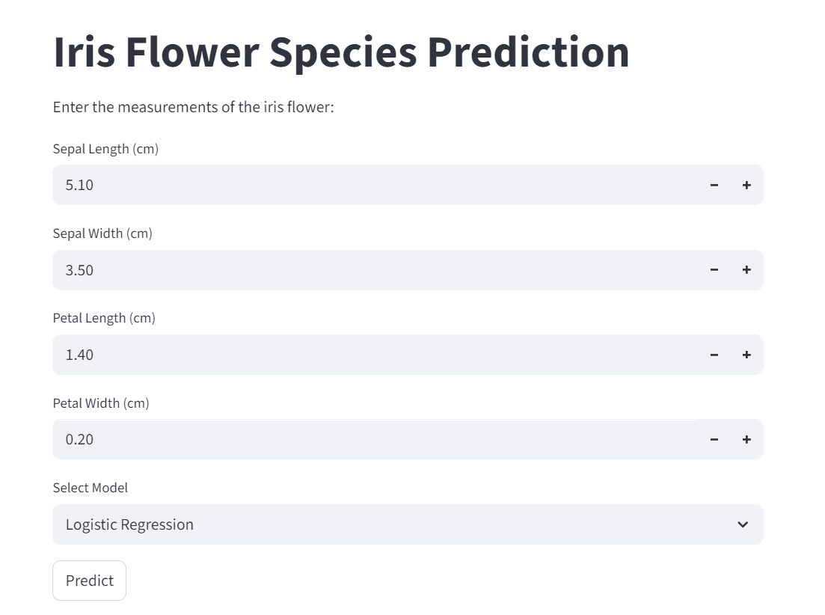
Fig No:8.1

8.2 Data Visualization

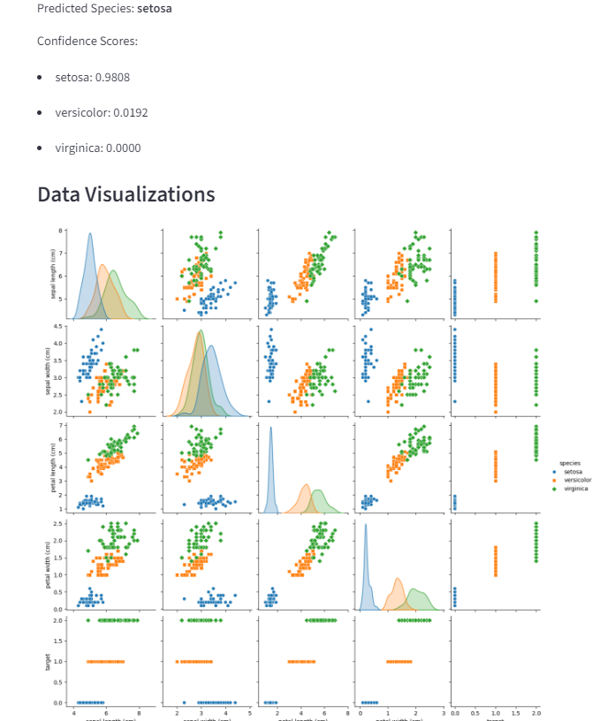

Fig No:8.2

8.3 Distribution Plots by Species

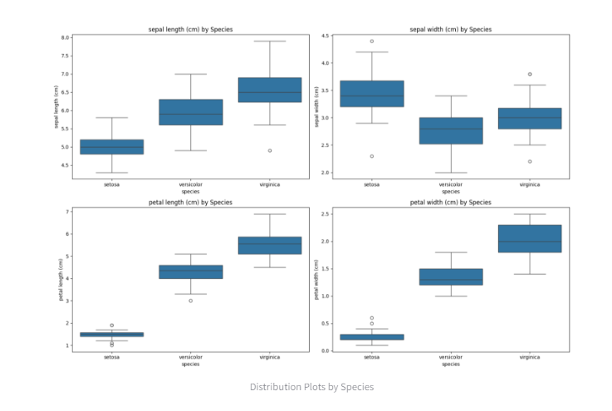

Fig No:8.3

8.3 Feature Correlation Heatmap

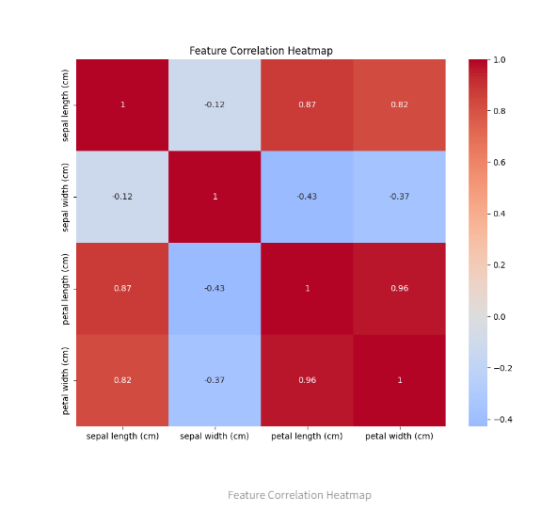

Fig No:8.4

8.5 Confusion Matrix-SVM

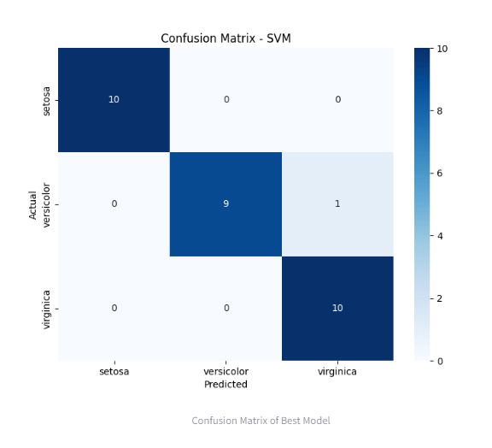

Fig No:8.5

CHAPTER-9
USER MANUAL

Using the Web Application (Most Common)
- Access the Application:
Open the provided URL (if deployed online) or run it locally as described above.

- Input Flower Measurements:
You will see four input sliders or number fields labeled:
Sepal Length
Sepal Width
Petal Length
Petal Width
Adjust the sliders or type in the values to match the flower you want to classify.

- Get the Prediction:
Click the "Predict" or "Classify" button.
The system will process your inputs and display the result prominently on the page.

- Understand the Output:
Predicted Species: The name of the predicted Iris species (e.g., Iris-virginica).
Confidence Score (Optional): Some versions may show a probability or confidence percentage (e.g., 95% confidence), indicating how sure the model is of its prediction.
Visualization (Optional): The app might display a bar chart showing the confidence levels for all three species.

E. Using the Command Line Interface (CLI)
Run the prediction script from your terminal.
The program will prompt you to enter each measurement one by one:
text
Enter Sepal Length (cm): 5.1
Enter Sepal Width (cm): 3.5
Enter Petal Length (cm): 1.4
Enter Petal Width (cm): 0.2
After entering the fourth value, the prediction will be displayed immediately:
text
[RESULT] The predicted Iris species is: Iris-setosa

CHAPTER-10
CONCLUSION
The Iris Flower Classification project demonstrates the power and effectiveness of machine learning in solving real-world classification problems. By analyzing features such as sepal length, sepal width, petal length, and petal width, the model can accurately predict the species of an iris flower — Setosa, Versicolor, or Virginica. Through techniques like data preprocessing, model training, and performance evaluation, this project highlights how data-driven approaches can lead to intelligent decision-making and pattern recognition in nature-inspired datasets.
Overall, this project not only enhances understanding of supervised learning concepts but also serves as a foundation for more complex classification systems. It provides valuable insights into data visualization, algorithm comparison, and model optimization. The successful implementation of this project proves that even simple datasets can be powerful tools for learning and experimentation in the field of artificial intelligence and data science.

CHAPTER 11
FUTURE ENHANCEMENT

- Expanded Species Classification – Extending the system to classify a wider variety of flower species beyond the classic Iris dataset.
- Adaptive Learning – Implementing self-updating models that improve accuracy as more flower data is collected over time.
- Integration with Educational and Research Tools – Developing APIs or plugins to integrate the system into botanical research software, mobile apps, or learning platforms for easy accessibility.
- Real-Time Classification – Deploying the system to analyze flower measurements on-the-go, allowing instant species prediction in the field using sensors or mobile devices.

Appendix: BIBLIOGRAPHY

Book References:
- Fisher, R. A. (1936). The Use of Multiple Measurements in Taxonomic Problems. Annals of Eugenics, 7(2), 179–188.
→ Introduces the Iris dataset and demonstrates statistical methods for classifying iris species.
- Duda, R. O., Hart, P. E., & Stork, D. G. (2001). Pattern Classification. Wiley.
→ Covers machine learning and pattern recognition techniques used for classifying flowers and other datasets.
- Kuhn, M., & Johnson, K. (2013). Applied Predictive Modeling. Springer.
→ Discusses practical applications of predictive modeling, including classification of plant species.
Web References:
- GeeksforGeeks. (2021). Iris Flower Classification using Machine Learning.
Available at: https://www.geeksforgeeks.org/iris-flower-classification-using-machine-learning/
- Kaggle. (2020). Iris Dataset.
Available at: https://www.kaggle.com/datasets/uciml/iris
- Towards Data Science. (2019). Building an Iris Flower Classifier from Scratch Using Python.
Available at: https://towardsdatascience.com/building-an-iris-flower-classifier-from-scratch-using-python-9f7f3f453d3f
- Analytics Vidhya. (2020). Predicting Iris Flower Species using Machine Learning.
Available at: https://www.analyticsvidhya.com/blog/2020/11/predicting-iris-flower-species-using-python.

